REF 2029: Guidance and information

Contribution to Knowledge and Understanding

Nomination of outputs for review

### Before you start

Make sure your Pure record is up to date, tell us about any newly accepted or published publications.

Send an email to [paperaccepted@abdn.ac.uk](mailto:paperaccepted@abdn.ac.uk) along with the confirmation e-mail or letter from your journal or publisher and the final accepted version of the output. You can also tell [paperaccepted@abdn.ac.uk](mailto:paperaccepted@abdn.ac.uk) about any publications that you think might be missing from Pure.

### What to Nominate

Nominate an output that is eligible and one which you think will rate well in the REF exercise. Before nominating, check that the output.

* meets the REF definition of research[1]
* contains original research, where you have made a distinct and substantial contribution to the output
* has been published, including early online publication, after 1 January 2021
* is openly accessible where appropriate. If the item is a journal article or a conference proceeding with an ISSN, the publication needs to meet the [REF open access requirements](https://2029.ref.ac.uk/guidance/ref-2029-open-access-policy/).

### Nominate an output in Pure

Log into Pure <https://pure.abdn.ac.uk/admin>

From your personal workspace click on “Research Outputs (xx)”

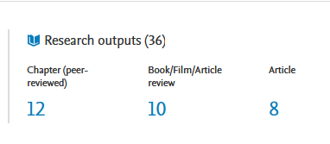

Scroll through the list of outputs or type the title into the search bar near the top of the screen, to find the item that you want to nominate for review.

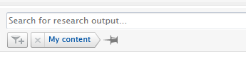

If using the search bar, type in the title, or a few key words from the title, and press the return key to search.

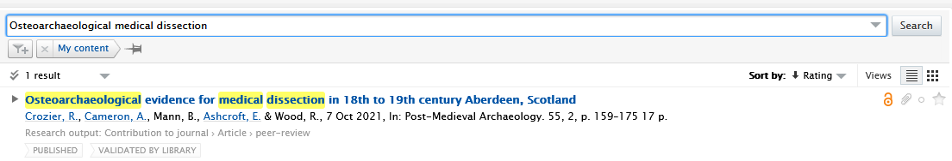

**Open the output and nominate for Review.**

Click on the title of the output to open the record

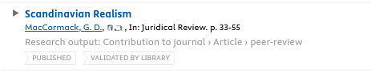

An editing window will open

From the menu on the left-hand side, click on REF 2029 reviews, then click on “Add Review”

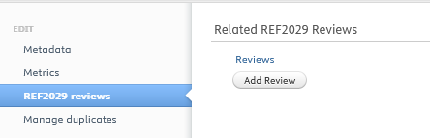

If a review request is already visible in this section, you do not need to nominate the output again.

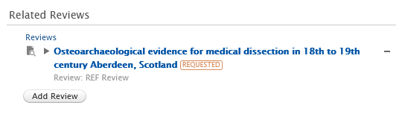

The type of review is pre-populated as REF Review.

If the work being nominated for review is a draft item, please change the review type to REF Review (Draft Content)

Click on REF Review under ‘Type’ to select from the drop-down options and select REF Review (Draft Content).

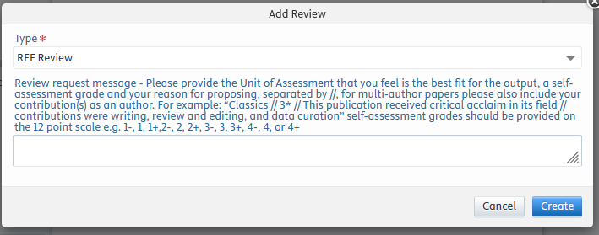

Enter the Unit of Assessment that you feel is the best fit for the output, the anticipated grade or indicative rating that you think the output might achieve, the reason why you would like the output to be reviewed or your justification for the rating, and your contribution as an Author separated by //.

For example, “Education // 3+ // text describing the reason for proposing or justification for the rating // text outlining your contribution to the work”.

Text can be prepared in advanced and copied and pasted into the box. You can also use the keyboard shortcut ctrl+c to copy and ctrl+v to paste

**Confirm the review request and save the record**

Confirming the review request is a two-step process, you need to create the review request and then save the publication record.

Click on create at the bottom right of the window, to add the review to the record.

An added review should look like the image below.



Once the review shows on the screen click on **save** at the bottom of the window to save the request.

Image of the save button in Pure

Clicking on save will notify the review administrators and begin the process of sending your output to reviewers.

A short video showing the process for nominating an output for review is available at <https://abdn.cloud.panopto.eu/Panopto/Pages/Viewer.aspx?id=dc381cc2-52fe-4492-8224-b24c009dc27d> please note this video does not contain any audio.

Once the nominations are uploaded to Pure review administrators will be notified and the process of sending your output to reviewers will begin.

1. For the purposes of the Research Excellence Framework (REF), research is defined as a process of investigation leading to new insights, effectively shared.   It **includes** work of direct relevance to the needs of commerce, industry, and to the public and voluntary sectors; scholarship; the invention and generation of ideas, images, performances, and artefacts including design, where these lead to new or substantially improved insights; and the use of existing knowledge in experimental development to produce new or substantially improved materials, devices, products and processes, including design and construction. It **excludes** routine testing and routine analysis of materials, components and processes such as for the maintenance of national standards, as distinct from the development of new analytical techniques. It also **excludes** the development of teaching materials that do not embody original research.