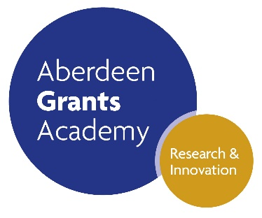

Find out how DASA works with organisations to find and fund innovation. DASA and CENSIS will be hosting an event on 22 May 2019 at The Lighthouse, Glasgow, aimed at interested parties from academia and industry.

It is free to attend and there are opportunities to book one-to-one sessions. Register in advance so you don’t miss out.

The [Scottish Universities Life Sciences Alliance](https://www.sulsa.ac.uk/) has recently launched some resources for [**Post-Academic Careers**](https://www.sulsa.ac.uk/careers/)for early career researchers. You can also sign up for updates on their Careers Fair, which be held later in the year and will feature case studies and practical workshops.